|  |  |
| --- | --- |
| GU-Group-logo_1  TA logo | Project Specs  Orange Swipe & Win  ver.1.2 |

**Table of Contents**

[1. Version History 3](#_Toc19119807)

[2. Project ID 4](#_Toc19119808)

[3. Project Details 5](#_Toc19119809)

[4. Project Specs 5](#_Toc19119810)

[4.1. Technical stakeholders 5](#_Toc19119811)

[4.2. APIs needed 5](#_Toc19119812)

[4.2.1.1. Bedbug 🡪 SmartLink side 5](#_Toc19119813)

[4.2.1.2. SmartLink 🡪 Bedbug side 5](#_Toc19119814)

[4.2.1.3. SmartLink 🡪 TA (via the VPN) 5](#_Toc19119815)

[4.2.1.4. TA 🡪 SmartLink (via the VPN) 6](#_Toc19119816)

[4.2.1.5. Orange 🡪 SmartLink 6](#_Toc19119817)

[4.3. Project Description 6](#_Toc19119818)

[4.3.1. Subscription service 6](#_Toc19119819)

[4.3.1.1. General 6](#_Toc19119820)

[4.3.1.2. Registration 7](#_Toc19119821)

[4.3.1.3. Registration process / Subscription 🡪 Trivia 10](#_Toc19119822)

[4.3.1.4. Billing 10](#_Toc19119823)

[4.3.1.5. One-time payment 12](#_Toc19119824)

[4.3.1.6. Content awarding 13](#_Toc19119826)

[4.3.1.7. Opt-out 13](#_Toc19119827)

[4.3.1.8. Re-opt-in 14](#_Toc19119828)

[4.3.1.9. Reset password process 15](#_Toc19119829)

[4.4. Prizes & Winners 16](#_Toc19119830)

**[4.4.1.](#_Toc19119831)****[Main Prizes](#_Toc19119831)** [16](#_Toc19119831)

[4.5. Black Hours / Days 17](#_Toc19119832)

[4.6. Broadcasting 17](#_Toc19119833)

**[4.6.1.](#_Toc19119834)****[Bulk](#_Toc19119834)** [17](#_Toc19119834)

**[4.6.1.1.](#_Toc19119835)****[Bulk connection](#_Toc19119835)** [18](#_Toc19119835)

**[4.6.1.2.](#_Toc19119836)****[Bulk rules](#_Toc19119836)** [18](#_Toc19119836)

**[4.6.2.](#_Toc19119837)****[Teasers](#_Toc19119837)** [18](#_Toc19119837)

[4.7. Additional Keywords 19](#_Toc19119838)

[5. Reports 20](#_Toc19119839)

[5.1. Default Reports 20](#_Toc19119840)

[5.2. Extra Reports 20](#_Toc19119841)

[6. Reporting Accounts & User Roles 21](#_Toc19119842)

[6.1. User Roles 21](#_Toc19119843)

[6.2. Reporting Accounts 21](#_Toc19119844)

[6.3. Roles Information 21](#_Toc19119845)

[7. “Swipe & Win” Rewarding points scheme 23](#_Toc19119846)

[8. Contact Details 26](#_Toc19119847)

[9. Other material (e.g. Campaign flows) 27](#_Toc19119848)

# Version History

|  |  |  |  |  |
| --- | --- | --- | --- | --- |
| **Version Number** | **Version Date** | **Revised by** | **Description** | **Reference in Document** |
| 1.0 | 2019-09-09 | Stefanos Bontas | Initial specs |  |
| 1.1 | 2019-09-10 | Stefanos Bontas | Amendments |  |
| 1.2 | 2019-09-11 | Stefanos Bontas | Reset password flow, short-code and USSD command updates |  |
|  |  |  |  |  |
|  |  |  |  |  |
|  |  |  |  |  |
|  |  |  |  |  |
|  |  |  |  |  |
|  |  |  |  |  |
|  |  |  |  |  |
|  |  |  |  |  |
|  |  |  |  |  |
|  |  |  |  |  |
|  |  |  |  |  |
|  |  |  |  |  |
|  |  |  |  |  |

# Project ID

|  |  |  |
| --- | --- | --- |
| **Promo Name** | | **Orange Swipe & Win** |
| **Promo Concept** | | **Daily subscription service with Swipe & Win digital game + on-demand games** |
| **Promo Type** | | **Daily subscription service** |
| **Country** | | **Egypt** |
| **Operator** | | **Orange** |
| **Partner** | | **SmartLink** |
| **Operator Details** | **Customer Base** | **21,300,000** |
| **Postpaid** | **Approx. 3,000,000** |
| **Prepaid** | **Approx. 18,000,000** |
| **Top-up events / Day** | **1,600,000 – 1,800,000** |
| **Duration** | | **1 year** |
| **Start Date** | | **2019-09-30** |
| **End Date** | | **2020-09-29** |
| **Local currency** | | **Egyptian Pound (EGP)** |
| **Local Time** | | **GMT + 2** |
| **Daylight saving time** | | **No** |
| **Time zones** | | **1** |
| **Local MSISDN Example (including Int. Prefix)** | | **0020 1210841295** |
| **Supported Languages** | | **Arabic (default), English** |
| **Arabic Max Length Characters / SMS** | | **70** |
| **English Max Length Characters / SMS** | | **140** |
| **Concatenation** | | **3 parts** |
| **Long Messages** | | **Yes** |
| **Reporting Languages** | | **English** |
| **Text Encoding** | | **TBC** |
| **Project Manager** | | **Stefanos Bontas** |

# Project Details

|  |  |
| --- | --- |
| **Subscription** | **Handled by SL** |
| **Web game** | **Swipe & Win** |
| **Responsible party for keeping points** | **SmartLink** |

# Project Specs

## Technical stakeholders

**Orange Swipe & Win”** service will be implemented by using the following topology:

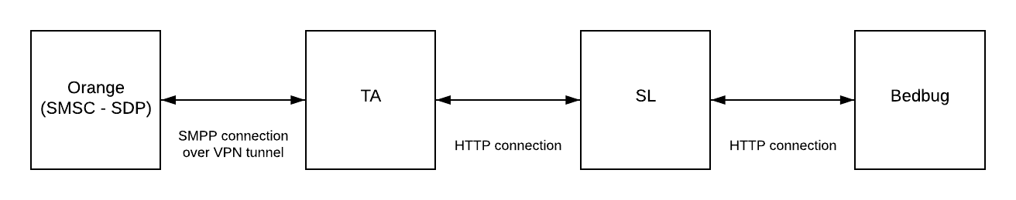

## APIs needed

## Bedbug 🡪 SmartLink side

|  |  |  |
| --- | --- | --- |
| API | Parameters to be passed | values to return |
| Subscribe | MSISDN, 4-digit PIN code | TBC |
| Reset password | MSISDN, 4-digit PIN code | TBC |
| Credit purchase | MSISDN | TBC |
| OTP send | MSISDN, OTP | TBC |
| Game end | MSISDN, correct questions, golden questions, silver questions, bronze questions | TBC |
| Points awarded | MSISDN | MSISDN, points |

## SmartLink 🡪 Bedbug side

|  |  |  |
| --- | --- | --- |
| API | Parameters to be passed | values to return |
| Subscribe | MSISDN | 4-digit PIN code |
| Unsubscribe | MSISDN | TBC |
| Add credit | MSISDN, number of credits | TBC |

## SmartLink 🡪 TA (via the VPN)

|  |  |  |
| --- | --- | --- |
| API | Parameters to be passed | values to return |
| MT send | TBC | TBC |
| Charge | TBC | TBC |
| Telco prize awarding | TBC | TBC |

## TA 🡪 SmartLink (via the VPN)

|  |  |  |
| --- | --- | --- |
| API | Parameters to be passed | values to return |
| Receive MO | TBC | TBC |
|  |  |  |
|  |  |  |

## Orange 🡪 SmartLink

|  |  |  |
| --- | --- | --- |
| API | Parameters to be passed | values to return |
| New “my Orange” app downloaders | MSISDN | TBC |

**Important note:** The above request/API is under approval by Orange security team.

## Project Description

## Subscription service

## General

|  |  |
| --- | --- |
| **Description / Notes** | **“Orange Swipe & Win”** will be an Orange branded service which has the objective to boost both the recruitment and usage of “my Orange” app, the self-care application of Orange Egypt. The service is targeted to be launched on 2019-xx-xx.  The service will be consisted of:   * Daily subscription service * The Swipe & Win web-game, which will be embedded to “my Orange” app by using Webview and be also available via web   User build-up points for the monthly top-scorer prize (55,000 EGP in cash). The following table illustrates the service’s daily prize structure.  Orange’s customers will be invited to join this service via bulk SMS or other channels (IVR OBD, SAT push, online etc.).  All customers subscribing to the content service will enjoy **1 free trial day** (1 free game to be awarded valid until the end of the day for one and only time) and they’ll also be awarded with a free telco prize from Orange (TBC) valid for a limited time. This means that the first “swipe & Win” credit will be free of charge and limited for 1 day validity. After the expiration of the free trial day (second day onwards), the subscription is automatically converted to “paid” at a cost of **EGP 2.00** per day. In case of re-opt in, the user will be charged immediately (no multiple free period applies).  Upon every successful charging, the customer will be awarded with 10 points more than the previous day and will be also awarded with 1 ephemeral “Swipe & Win” credit. The daily subscription points follow the below format:  • Registration day: 10 points free of charge  • 1st charged day: 20 points  • 2nd charged day: 30 points  …  Nth charged day: (points awarded the previous charged day) + 10  Formula for calculating subscription points: **points = (10 \* times charged) + 10**  User will also have the option to purchase up to five (5) credits for on demand games maximum via the web app.  Upon logging-in into the app, user may consume the awarded credit(s) by starting a new round. Every round lasts for 55 seconds where question headers (statements) are being served along with relevant photos. The user swipes right for Right and Left for Wrong. Each wrong replied question also decreases the available game time 5 seconds.  At the end of the round, the correct answers are being translated into points for the monthly draw.  Apart from the subscription & web-game, the service will also award the users for being engaged with “my Orange” self-care app, meaning that various rewarding schemes will be applied in order for the app to be promoted (**see section 7 below**). |

## Registration

|  |  |  |
| --- | --- | --- |
| **Description / Notes** | | The registration can occur via:   1. USSD channel (most common) 2. Online channel (web-app) 3. SMS channel   Below you may find the description for each opt-in channel:   1. **USSD channel (most common)**    1. User receives the bulk message and responds by calling the USSD dial #50#    2. TA Telecom receives the call and generates a fake MO    3. SL receives the fake MO and checks if the user has already been subscribed       1. If subscribed, the “already participate” reply MT should be served to the user       2. Else we continue to the next step    4. SL subscribes the user to the service    5. SL notifies Bedbug for the user subscription via the Subscribe user API (curl --location --request GET "http://locahost:3031/api/api\_sub.aspx?msisdn=201210841295")    6. Bedbug subscribes the user to the service, awards one (1) ephemeral credit and generates a 4 digits PIN code and notify SL    7. Then SL to send the 4-digits password along with the welcome message    8. SL to notify Orange for crediting the free telco prize    9. Orange to inform the user for the free prize awarding with a new MT 2. **Online (web-app) supposing that we have user’s MSISDN (via data or app)**    1. User enters Swipe & Win and taps register    2. User is already authenticated and BB will call SL’s subscription API in order to get register    3. SL to subscribe the user and respond success to BB so as for the success screen to be appeared    4. SL to check “my Orange” status app. If downloaded, the user should be awarded with 1,000 free points and receive a special welcome MT, if not, the user will be awarded with 10 points and receives the regular MT   The 4-digit password should be sent along with the welcome MT.   * 1. SL to notify Orange for crediting the free telco prize   2. Orange to inform the user for the free prize awarding with a new MT  1. **Online (web-app) supposing that we haven’t user’s MSISDN (Wi-Fi)**    1. User enters Swipe & Win and taps register    2. User enters his/her MSISDN    3. BB to generate the 4-digit One Time Password (OTP) and forward it to SL    4. SL to check if the user has already been subscribed to the service and he’s active (active = not opted-out)       1. If already subscribed, to respond to BB accordingly so as for the “already subscribed” error message to appear on the screen and user to be redirected to login page   **Warning:** Only 3 MSISDN checks should be allowed from each IP address   * + 1. If not subscribed, we continue with the next step   1. SL to send the OTP code via MT   2. User submits the OTP code      1. If success, BB to generate the user’s password and forward a sub request to SL      2. If not success, an error message to appear on the screen so as for the user to retry   3. SL to subscribe the user and respond success to BB so as for the success screen to be appeared   4. SL to check “my Orange” status app. If downloaded, the user should be awarded with 1,000 free points and receive a special welcome MT, if not, the user will be awarded with 10 points and receives the regular MT   The 4-digit password should be sent along with the welcome MT.   * 1. SL to notify Orange for crediting the free telco prize   2. Orange to inform the user for the free prize awarding with a new MT  1. **SMS channel (least common)**    1. User receives the bulk message and responds by sending a keyword to the short-code 5055    2. SL receives the MO and checks if the user has already been subscribed       1. If subscribed, the “already participate” reply MT should be served to the user       2. Else we continue to the next step    3. SL subscribes the user to the service    4. SL notifies Bedbug for the user subscription via the Subscribe user API (curl --location --request GET "http://locahost:3031/api/api\_sub.aspx?msisdn=201210841295")    5. Bedbug subscribes the user to the service, awards one (1) ephemeral credit and generates a 4 digits PIN code and notify SL    6. Then SL to send the 4-digits password along with the welcome message    7. SL to notify Orange for crediting the free telco prize    8. Orange to inform the user for the free prize awarding with a new MT |
| **Short code** | | **5055** |
| **Throughput** | | **500 TPS** (requested – TBC upon Orange approval) |
| **Keywords** | | **TBC** |
| **USSD opt-in code** | | **#50#** |
| **Opt-in guaranteed prize** | | **A telco bundle (TBC)** |
| **Points upon registration** | | 10 (for one and only time upon being subscribed for the first time) |
| **Tariff** | | **1 free day is being granted for one and only time. After expiring (or user opt-outs and then re-opts in within the same day), the following charging points apply:**   1. **2.00 EGP** (200 piasters - full charge): 100% of daily points to be awarded 2. **1.50 EGP** (150 piasters - 1st partial point charge): 75% of daily points to be awarded 3. **1.00 EGP** (100 piasters - 2nd partial point charge): 50% of daily points to be awarded 4. **0.75 EGP** (75 piasters - 3rd partial point charge): 40% of daily points to be awarded 5. **0.50 EGP** (50 piasters - 4th partial point charge): 25% of daily points to be awarded, to be rounded up to the next integer if decimal 6. **0.25 EGP** (25 piasters - 5th partial point charge): 15% of daily points to be awarded   The Swipe & Win credit to be awarded with the first charge of the day. If user is being billed again for collecting the 2 EGP, no other credit to be awarded. |
| **Channels** | **SMS** | Yes No |
| **Web** | Swipe & Win website |
| **USSD** | TA to create a fake MO (TBC) |

## Registration process / Subscription 🡪 Trivia

|  |  |  |
| --- | --- | --- |
| **MTs After Opt-In** | **Message Type** | **Delay** |
| 1st MT | Welcome message | Immediately after being subscribed |

## Billing

|  |  |  |  |  |  |  |  |  |  |  |  |  |  |  |  |  |  |  |  |  |  |  |  |  |  |
| --- | --- | --- | --- | --- | --- | --- | --- | --- | --- | --- | --- | --- | --- | --- | --- | --- | --- | --- | --- | --- | --- | --- | --- | --- | --- |
| **Description / Notes** | **The billing mechanism is described below:**   1. **Users’ segmentation (to be the same with Orange 100x100):**  |  |  |  |  | | --- | --- | --- | --- | | # | Segment | Billing sequence | Daily attempts | | 1 | Charged within the last 9 days  (fully or partially) | 2 EGP 🡺  1 EGP | 23 | | 2 | Charged before 10 days more than once | 2 EGP 🡺  1 EGP | 6 | | 3 | Charged more than once | 0.50 EGP | 3 | | 4 | Never charged users | 0.25 EGP | 0.5 | | 5 | Default (new & re opted-in users) | 2 EGP 🡺 1 EGP | 24 |  1. **The billing mechanism**    1. SL to initiate the billing       1. If failed reply, no action to be taken       2. If success reply to be received, we continue to the next step    2. SL to award the user with points based on the points scheme    3. SL to notify BB in order for a daily ephemeral credit to be awarded to the user    4. SL to check if the user has downloaded the “my Orange” app       1. If user has downloaded the app, SL to award him/her with the respective points and then to push a normal renewal MT. For example:   *Congratulations, 100 points are yours because you’re my Orange app customer. Follow the link* [*bit.ly/swipe*](file:///C:\Users\stefanos.bontas\Desktop\bit.ly\swipe)*, play your daily round and get closer to the Cash!*   * + 1. If user has **not** downloaded the app, SL to award him/her with the respective points and then to push a special renewal MT. For example:   *Congratulations, 20 points are yours. Follow the link* [*bit.ly/swipe*](file:///C:\Users\stefanos.bontas\Desktop\bit.ly\swipe)*, play your daily round and you can win 55,000 pounds in Cash!*  *Want to get closer? Download “my Orange” app and 1,000 points will be yours!* |
| **Throughput** | 400 TPS (requested – To be Approved by Orange) |
| **Process runs by** | SmartLink |
| **Partial billing** | 1. **2.00 EGP** (200 piasters - full charge): 100% of daily points to be awarded 2. **1.50 EGP** (150 piasters - 1st partial point charge): 75% of daily points to be awarded 3. **1.00 EGP** (100 piasters - 2nd partial point charge): 50% of daily points to be awarded 4. **0.75 EGP** (75 piasters - 3rd partial point charge): 40% of daily points to be awarded 5. **0.50 EGP** (50 piasters - 4th partial point charge): 25% of daily points to be awarded, to be rounded up to the next integer if decimal 6. **0.25 EGP** (25 piasters - 5th partial point charge): 15% of daily points to be awarded |
| **Backdated billing** | Days back: 3  Grace period for receiving free content: 3 |
| **Billing attempts** | Segments definition & Billing attempts: [Link](file:///Z:\___New_Project_Template\Specs%20&%20Documentation\_Resources\Segments%20&%20Billing%20attempts_template.xlsx) |
| **VPN** | Yes No |
| **External Resources** | API documentation: Link  VPN details form: Link |

## One-time payment

|  |  |
| --- | --- |
| **Description / Notes** | **Purchase one (1) round on-demand flow is the following:**  **Important note:** This feature will be available only via the web-app.   1. A logged-in user presses the “Buy another round” button 2. BB to initiate an on-demand request by calling SL’s API 3. SL tries to charge 2 EGP on the sport via direct billing through SDP    1. If unsuccessful, an error code to be returned to BB in order for an error message to appear on the screen (TBC for error messages)    2. If successful, SL to notify BB with success response 4. SL to award 1 credit to the user and BB to inform him/her via a success screen 5. SL to check if user has downloaded “my Orange” app    1. If yes, points to be added to the user according to the points’ scheme and special MT to be sent to the user. For example:   *“Surprise form Orange:*  *1,000 extra points are yours because you belong to my Orange app users! Redeem your round to get closer to the 55,000 pounds this month!”*   * 1. If not, no extra points to be added to the user |
| **Available via** | APIs |
| **Process runs by** | SmartLink |
| **Billing** | **2.00 EGP** |

## Content awarding

|  |  |
| --- | --- |
| **Description / Notes** | 1. SL to initiate the billing    * 1. If failed reply, no action to be taken      2. If success reply to be received, we continue to the next step 2. SL to award the user with points based on the points scheme 3. SL to notify BB in order for a **daily ephemeral credit** to be awarded to the user 4. SL to check if the user has downloaded the “my Orange” app    * 1. If user has downloaded the app, SL to award him/her with the respective points and then to push a normal renewal MT. For example:   *Congratulations, 100 points are yours because you’re my Orange app customer. Follow the link* [*bit.ly/swipe*](file:///C:\Users\stefanos.bontas\Desktop\bit.ly\swipe)*, play your daily round and get closer to the Cash!*   * + 1. If user has **not** downloaded the app, SL to award him/her with the respective points and then to push a special renewal MT. For example:   *Congratulations, 20 points are yours. Follow the link* [*bit.ly/swipe*](file:///C:\Users\stefanos.bontas\Desktop\bit.ly\swipe)*, play your daily round and you can win 55,000 pounds in Cash!*  *Want to get closer? Download “my Orange” app and 1,000 points will be yours!* |
| **Content delivery every** | Daily basis |
| **Free days** | 1 |
| **Content type** | Swipe & Win credit |
| **Draw chances & credits** | Chances & credits by billing point: Link |

## Opt-out

|  |  |
| --- | --- |
| **Description / Notes** | **Important note:** The opt-out process will be available only via the SMS channel.  **The opt-out process via SMS should be the following one:**   1. User sends an opt-out keyword 2. SL to check if the user is a subscriber of the service    1. If **not** a subscriber, to reply user with an invalid reply and exclude him from future bulk (**blacklisted**). For example:   *Dear user, you are not participating to Swipe & Win service!*   * 1. If he/she is an already opted-out subscriber, to reply user with the already opted-out reply. For example:   *Dear user, you have already opted-out from Swipe & Win service!*   * 1. If user existing subscriber, to continue with the next step  1. SL to check if the opt-out keyword is valid:    1. If **not** valid, to reply user with an invalid reply. For example:   *Dear user, you are already participating to Swipe & Win service:*  *For opting-out, send STOP to 5055*  *For starting a new round, please follow the link:* [*http://bit.ly/swipe*](http://bit.ly/swipe)  *Terms & Conditions apply*   * 1. If keyword is valid, to continue with the next step  1. SL to unsubscribe the user from the service 2. SL to notify BB so as to lock the login process 3. SL to send the opt-out MT to the user. For example:   *Dear user, you have successfully opted-out from Swipe & Win service!* |
| **Short code** | **5055** |
| **Keywords** | STOP, Stop, stop, EXIT, Exit, exit, Unsub  قف,الغاء, إلغاء, ألغاء,ايقاف,أيقاف,إيقاف, خروج |
| **Automatic opt-out after consecutive failed billing attempts** | No |
| **Web opt-out** | No |

## Re-opt-in

|  |  |  |
| --- | --- | --- |
| **Description / Notes** | | Re-opt-in to follow the opt-in flow but no extra points or free day / round to be awarded to the user. A re-opted-in user should be attempted to be charged immediately. |
| **Short code** | | **5055** |
| **Keywords** | | SUB, Sub, sub, 1, WIN, Win, win, YES, Yes, yes, 1-9 (Latin numbers) |
| **Re-opt-in on** | **the registration day** | Subscriber gets charged |
| **an already billed day** | Subscriber does not get charged |
| **free period** | Subscriber loses free day |
| **a day that credit has already been served** | No action |

## Reset password process

|  |  |
| --- | --- |
| **Description / Notes** | 1. A not logged-in user insert his/her MSISDN and presses reset password in the web-app 2. BB to create a new OTP code 3. BB to send the OTP code to SL 4. SL to forward the MT to the user. For example:   *To reset your password, enter the PIN 1234*  *Hurry up, it’ll be expired soon!*   1. User to submit the OTP in the web-app 2. BB to check if the OTP has been expired    1. If so, an error message to be generated in the web-app and then the user may restart the whole process by pressing the “Resend” button    2. If not expired, we continue with the next step 3. BB to check if this input is correct.    1. If not correct, an error message to appear and the user will be able to re-input the OTP as long as it hasn’t been expired    2. If correct, BB to generate the new 4-digits password and to be sent to SL. As long as the user is already authenticated via the OTP, a success screen to be appear and the user to be redirected to the home page 4. SL to send the new password to the user |
| **Short code** | **5055** |

* + 1. **Web Game**

|  |  |
| --- | --- |
| **Description / Notes** | As shown in the flow. |
| **Game type** | Swipe & Win |
| **Game developed by** | Bedbug |
| **URL** | Swipe.orange.eg (currently under approval) |
| **Website hosted by** | Amazon |
| **Features** | Online registration in web game  User Authentication via “my Orange” app  On-demand purchases  Header Enrichment (TBC)  Account page (view points etc.)  Zero rated website |
| **Supported languages** | English Arabic (Arabic to be the default one) |
| **External Resources** | Website texts: Link |
| **External Resources** | Online Registration documentation: Link **(TBC)**  User Authentication documentation: Link **(TBC)**  Header Enrichment documentation: Link **(TBC)**  On-demand purchases documentation: Link **(TBC)** |

## Prizes & Winners

|  |  |
| --- | --- |
| **Description / Notes**  **/ Draw process** | As stated in the below table. |
| **Prize distribution** | Prize distribution template: Link  **(TBC)** |
| **Top Scorer** | Yes |

### **Main Prizes**

|  |  |  |  |  |  |  |  |  |  |  |
| --- | --- | --- | --- | --- | --- | --- | --- | --- | --- | --- |
| **Type** | **When** | **What** | **Award Method** | | | **Based on** | **Eligibility** | **Results** | | **Times to win the prize** |
| **Top Scorer** | **Draw** | |
| **Ballot** | **Automatic** | **Winners** | **Substitutes** |
| **Monthly** | At the end of the month | 55,000 EGP |  |  |  | Total points | Users who have been charged at least once during the respective period | 1 |  | Only once |

## Black Hours / Days

|  |  |  |  |  |
| --- | --- | --- | --- | --- |
|  | **Bulk Broadcast** | | **Teaser Broadcast** | |
| **Black Hours** | **Start Time** | 21:00 (local time zone of operator) | **Start Time** | 21:00 (local time zone of operator) |
| **End Time** | 09:00 (local time zone of operator) | **End Time** | 09:00 (local time zone of operator) |
| **Black Days, specify: Friday (prayer time)** | **Start Time** | 21:00 (local time zone of operator) | **Start Time** | 21:00 (local time zone of operator) |
| **End Time** | 13:00 (local time zone of operator) | **End Time** | 13:00 (local time zone of operator) |

## Broadcasting

### **Bulk**

|  |  |
| --- | --- |
| **Description / Notes** | We have requested a dedicated short-code from Orange for broadcasting the bulk (in order to have more available TPS). |
| **Bulk runs by** | SmartLink |

|  |  |
| --- | --- |
| **Type of bulk** | TBC |
| **Bulk short code** | TBC |
| **Throughput** | 500 TPS (initially requested, it is up to Orange to approve it) |
| **Text encoding** | Same as default |
| **New line separator** | Same as default |
| **Concatenation** | Same as default |
| **Long messages** | Same as default |

### **Bulk connection**

|  |  |
| --- | --- |
| **Description / Notes** | Bulk connection to be via VPN tunnel with TA by using HTTP protocol (as in the Orange 100x100 service).  More details to be shared upon agreeing on the parameters with TA. |
| **External Resources** | API documentation: Link  VPN details form: Link |

### **Bulk rules**

|  |  |
| --- | --- |
| **For non – participants** | |
| **Rules** | No user to receive more than 1 bulk MT twice within 15 days’ time. |

### **Teasers**

|  |  |
| --- | --- |
| **Description / Notes** | We should be able to send teasers and monitor the performance. The following segments should be created:   1. “my Orange” app smartphone users 2. Smartphone users who haven’t downloaded the “my Orange” app 3. Feature phone users with no interaction with “my Orange” app 4. Subscribers who never interacted with Swipe & Win web-app |

|  |  |
| --- | --- |
| **Teaser short code** | **5055** |
| **Concatenation** | Same as default |
| **Long messages** | Same as default |
| **Encoding** | Same as default |
| **New line separator** | Same as default |

#### **Default Teasers**

|  |  |
| --- | --- |
| **Description / Notes** | - |
| **External Resources** | Default teasers template: Link |

## Additional Keywords

|  |  |  |  |  |
| --- | --- | --- | --- | --- |
| **Action** | **Default language (AR)** | **EN** | **Short code** | **Points** |
| Help | HELP, Help, help | مساعدة | 5055 | 0 |
| Info | INFO, Info, info | مساعدة ,معلومات | 5055 | 0 |
| Opt-out | SCORE, Score, score | نقاطي ,نقاط | 5055 | 0 |

# Reports

## Default Reports

|  |  |
| --- | --- |
| **Description / Notes** |  |

|  |  |
| --- | --- |
| **UI Reports** | Summary  Daily  Hourly  Survival  Teasers Efficiency  Bulk Efficiency |

## Extra Reports

|  |  |
| --- | --- |
| **Description / Notes** | We do need all of the raw data (opt-ins, opt-outs and successful charges so as to configure a metabase report in parallel. |

|  |  |  |
| --- | --- | --- |
|  | **Report Type / Name** | **Report Definition** |
| **Extra Reports** | Invalid Keywords |  |
| Users opted-in per medium | **Users opt-in channel (medium):** To split the opt-in users based on the following opt-in channels:   1. USSD 2. Web opt-in 3. SMS |
| Swipe & Win service users insights | **Swipe & Win service users insights:**   1. % of them to be “my Orange” app downloaders 2. % of them to be smartphone users |

# Reporting Accounts & User Roles

## User Roles

|  |  |
| --- | --- |
| Clients or Organizations | Roles |
| SL - GU | Project Manager |
| Call Center | CC Agent |
| Orange Senior Mgmt | Manager |

## Reporting Accounts

|  |  |  |  |  |
| --- | --- | --- | --- | --- |
| Username | Password | Language | Organization | Role / Group |
| [Georgios.pantazis@gugroup.com](mailto:Georgios.pantazis@gugroup.com) |  | En | GU | Project Manager |
| [Panagiota.alexiou@gugroup.com](mailto:Panagiota.alexiou@gugroup.com) |  | En | GU | Project Manager |
| [Tarek.ammar@gugroup.com](mailto:Tarek.ammar@gugroup.com) |  | En | GU | Project Manager |
| [Stefanos.bontas@gugroup.com](mailto:Stefanos.bontas@gugroup.com) |  | En | GU | Project Manager |
| [Natasa.chaidogiannou@gugroup.com](mailto:Natasa.chaidogiannou@gugroup.com) |  | En | GU | Project Manager |
| [Metaxas.stellatos@gugroup.com](mailto:Metaxas.stellatos@gugroup.com) |  | En | GU | CC Agent |
|  |  |  |  |  |

## 

## Roles Information

|  |  |  |  |  |  |
| --- | --- | --- | --- | --- | --- |
| **Reports** | **Project Manager (SL-GU)** | **CC Agent** | **Orange Manager** |  |  |
| **General** | |  | | | |
| Summary |  |  |  |  |  |
| Daily |  |  |  |  |  |
| Hourly |  |  |  |  |  |
| Survival |  |  |  |  |  |
| Promo Efficiency Report |  |  |  |  |  |
| Executive summary report |  |  |  |  |  |
| **Analysis** |  |  |  |  |  |
| Revenue Distribution |  |  |  |  |  |
| **Campaign Management** |  |  |  |  |  |
| Promo Messages |  |  |  |  |  |
| Promo Schedule |  |  |  |  |  |
| Bulk Messages |  |  |  |  |  |
| **Call Center** |  |  |  |  |  |
| User dialogue |  |  |  |  |  |
| Change Language |  |  |  |  |  |
| Exclude from Bulk |  |  |  |  |  |
| Exclude from Teasers |  |  |  |  |  |
| Exclude from Contest |  |  |  |  |  |
| Exclude from All Prizes |  |  |  |  |  |
| Add User Points |  |  |  |  |  |
| **Winners** |  |  |  |  |  |
| Winners Weekly |  |  |  |  |  |
| Winners Monthly |  |  |  |  |  |
| Download Participants’ lists |  |  |  |  |  |
| **Upload** |  |  |  |  |  |
| Files Uploaded |  |  |  |  |  |
| Messages Uploaded |  |  |  |  |  |

# “Swipe & Win” Rewarding points scheme

|  |  |  |  |  |  |  |  |  |
| --- | --- | --- | --- | --- | --- | --- | --- | --- |
| **Name** | **Action** | **Extra points reward** | **Extra rounds reward** | **Other reward** | **Comments** | **How to track it** | **Responsible to track the event** | **Is API needed?** |
| **Correct question reply** | Every correct reply to award | 10 |  |  |  | Game interface | BB | BB🡪SL for adding points |
| **Registration bonus** | Subscribing via "my Orange" app | 100 | - | - | 100 points instead of 10 | Identify a redirection from "my Orange" app | SL | No |
| **On-demand bonus** | Purchase an on-demand credit while being "my Orange" app user | 1,000 | - | - | if not "my Orange" app user, no points to be awarded | Being flagged as "my Orange" app user upon successful purchasing of an on-demand round | SL | No |
| **Funday** | Login via "my Orange" app on Sunday | 2,000 | - | - | Upon starting the first round of the day | Identify a redirection from "my Orange" app | BB | Add points API |
| **Super 3** | Login via "my Orange" app on Monday | - | 3 | - |  | Identify a redirection from "my Orange" app | BB | No |
| **Double day** | Login via "my Orange" app on Tuesday | - | 1 | - | 1+1 upon purchasing 1 round on-demand | Identify a redirection from "my Orange" app | BB | No |
| **"my Orange" bonus** | Login via "my Orange" app on Wednesday | 1,000 | - | - | 1,000 points instead of the daily ones | Identify a redirection from "my Orange" app | BB | Add points API |
| **Bonus day** | Login via "my Orange" app on Thursday | 1,000 | - | - | 1,000 extra points with each Swipe & Win round | Identify a redirection from "my Orange" app | BB | Add points API |
| **Super weekend** | Login via "my Orange" app on Friday | - | 2 | - |  | Identify a redirection from "my Orange" app | BB | No |
| **Mega bonus** | Login via "my Orange" app on Saturday | 3,000 | - | - | Upon completing each Swipe & Win round | Identify a redirection from "my Orange" app | BB | Add points API |
| **1 game before monthly prize** | 1 day before monthly prize | 5,000 | - | - | Upon completing each Swipe & Win round | Identify a redirection from "my Orange" app | BB | Add points API |
| **Bronze Question** | Bronze Question | 500 | - | - | To be the 6th question to be served during **the first game of the day**  and to be served only to "my Orange" app users | Identify a redirection from "my Orange" app | BB | Add points API |
| **Silver Question** | Silver Question | 1,000 | - | - | To be the 6th question to be served during the **second game of the day** and to be served only to "my Orange" app users | Identify a redirection from "my Orange" app | BB | Add points API |
| **Golden Question** | Golden Question | 2,000 | - | Small bundle (whatever Orange can give us) | To be the 6th question to be served during the **third game of the day** and to be served only to "my Orange" app users - if Orange won't accept it, then a free round to be given away instead of the bundle | Identify a redirection from "my Orange" app | BB | Add points API & |
| **App download** | A Swipe & Win subscriber but not "my Orange" app user downloads the app | 3,000 | - | Small bundle (whatever Orange can give us) | We'll send teasers to this segment with CTA "Download my Orange app and a guaranteed prize is waiting for you! ..." | New download API call | SL | No |
| **Top-Up reward** | Pre-Paid users who top-up via the app | 2,000 | 1 |  | For topping up any amount via "my Orange" app - Only if Orange can share this info via API | Top-Up event API call | SL | Yes, add rounds |
| **Bill payment reward** | Post-Paid users who pay the bill via the app | 2,000 | 1 |  | For paying the monthly bill via "my Orange" app - Only if Orange can share this info via API | Bill payment API call | SL | Yes, add rounds |

# Contact Details

|  |  |  |
| --- | --- | --- |
| **Client PM**  **(subscription service)** | Name/Surname | George Maged Fawzy |
| e-mail | [george.mfawzy@orange.com](mailto:george.mfawzy@orange.com) |
| Mobile | 0020 1201332000 |
| Landline |  |
| IM (Hangouts/Skype) |  |
| **Client PM**  **(digital service)** | Name/Surname | Shaymaa Mohamed Mohamed El Zayat |
| e-mail | [shaimaa.zayat@orange.com](mailto:shaimaa.zayat@orange.com) |
| Mobile | 0020 1223194075 |
| Landline |  |
| IM (Hangouts/Skype) |  |
| **Client Technical Manager** | Name/Surname | Mahmoud Abdel Aziz |
| e-mail | [mahmoud.sassy@orange.com](mailto:mahmoud.sassy@orange.com) |
| Mobile |  |
| Landline |  |
| IM (Hangouts/Skype) |  |
| **Partner** | Name/Surname | Tamer Mohsen |
| e-mail | [tamer@smartlink.me](mailto:tamer@smartlink.me) (internal communication)  [egy.level1@gugroup.com](mailto:egy.level1@gugroup.com) (communication with Orange) |
| Mobile | 0020 1008432843  0020 1155575081 |
| Landline |  |
| IM (Hangouts/Skype) |  |
| **Partner Technical Manager** | Name/Surname |  |
| e-mail |  |
| Mobile |  |
| Landline |  |
| IM (Hangouts/Skype) |  |
| **Call Center Contact** | Name/Surname | Boshra Bahgat |
| e-mail | [boshra.bahgat@orange.com](mailto:boshra.bahgat@orange.com) |
| Mobile | 0020 1288401188 |
| Landline |  |
| IM (Hangouts/Skype) |  |

# Other material (e.g. Campaign flows)

* 1. **Opt-in via web or “my Orange” app with data available & PIN flow**

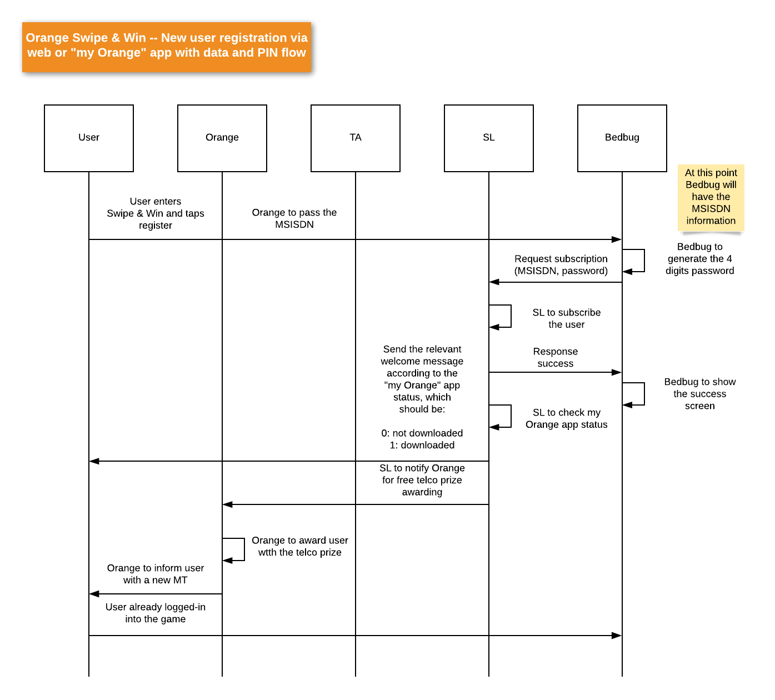

* 1. **Opt-in via web with wifi & PIN flow**

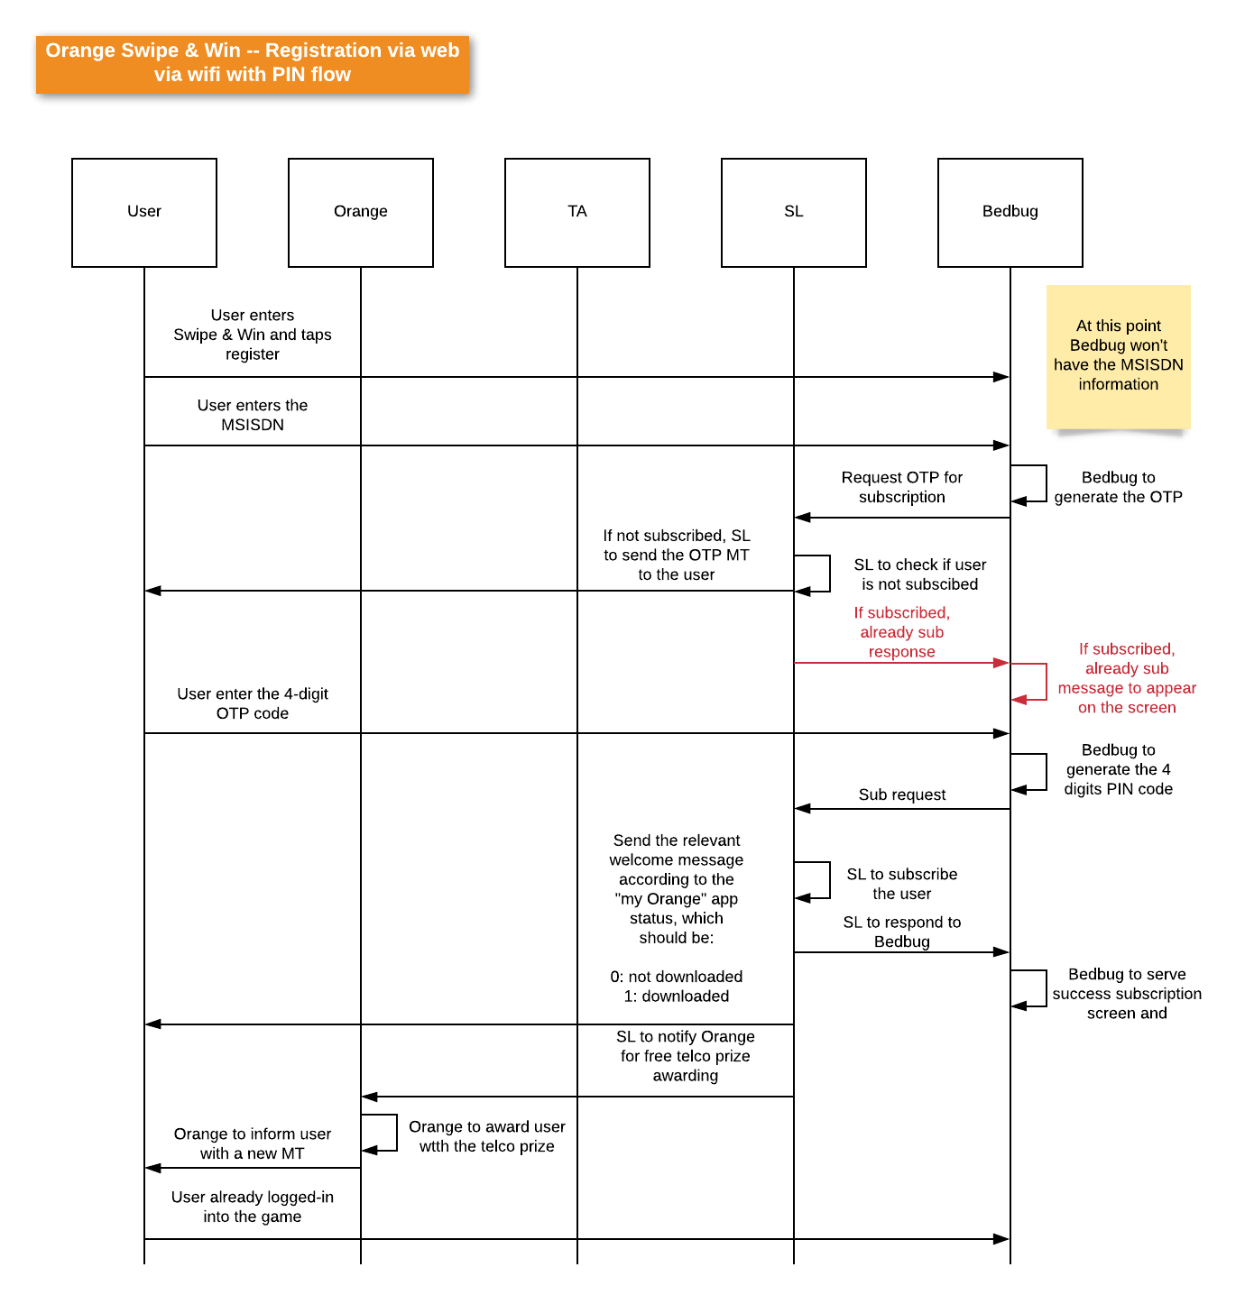

* 1. **Opt-in via USSD with PIN flow**

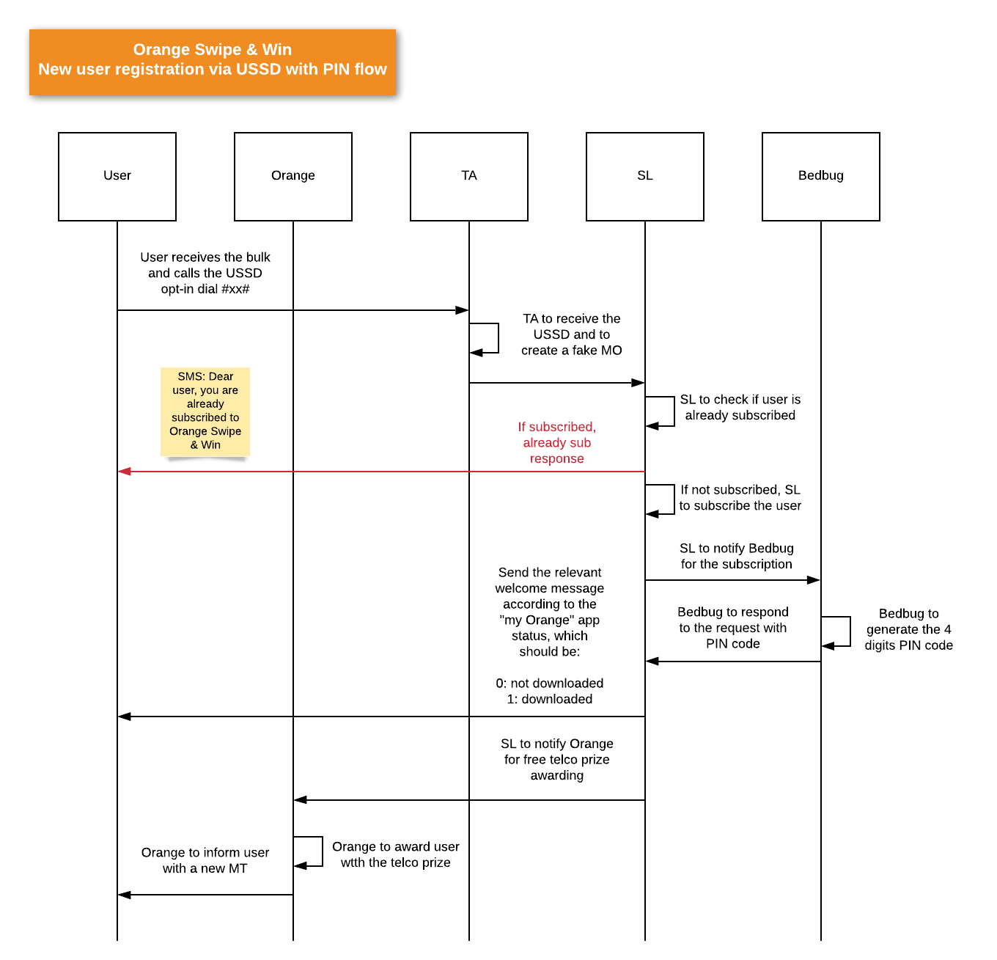

* 1. **Login via wifi – data (PIN flow)**

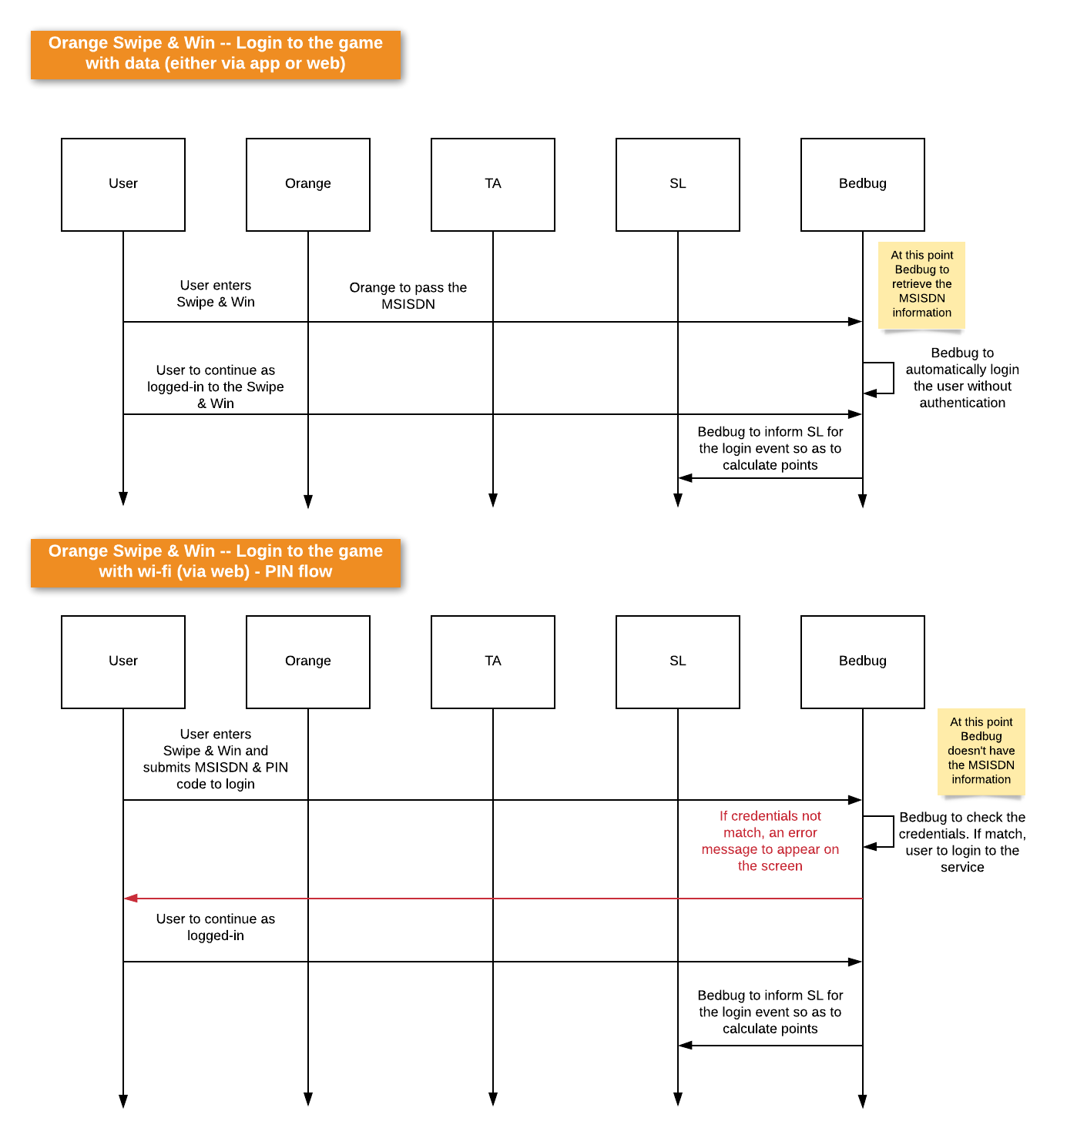

* 1. **Purchase on-demand rounds**

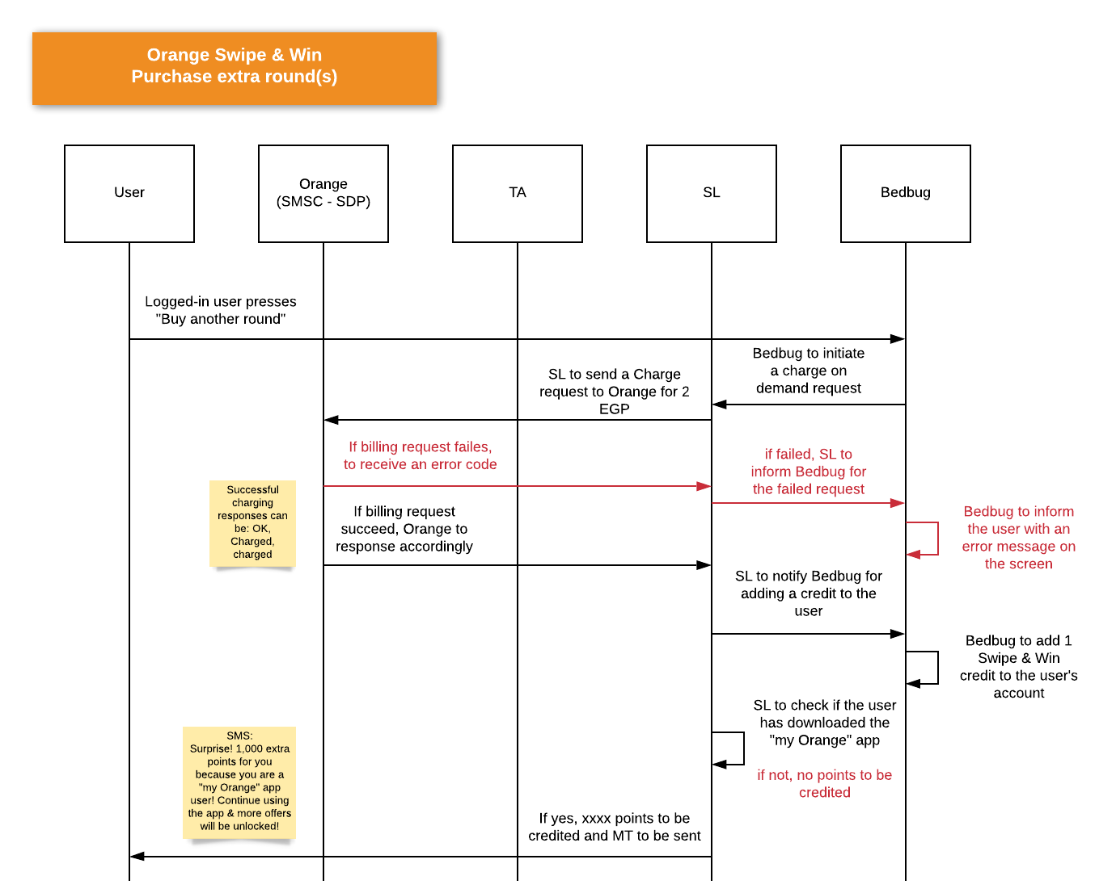

* 1. **Reset password process**

